Mill Rythe Infant School
(FOUNDATION)

Havant Road, Hayling Island, Hampshire PO11 0PA
Tel: 0239246 5531
Website: millrytheinfants.co.uk
E-mail: adminoffice@millrythe-inf.hants.sch.uk

Headteacher: Lucy Ford
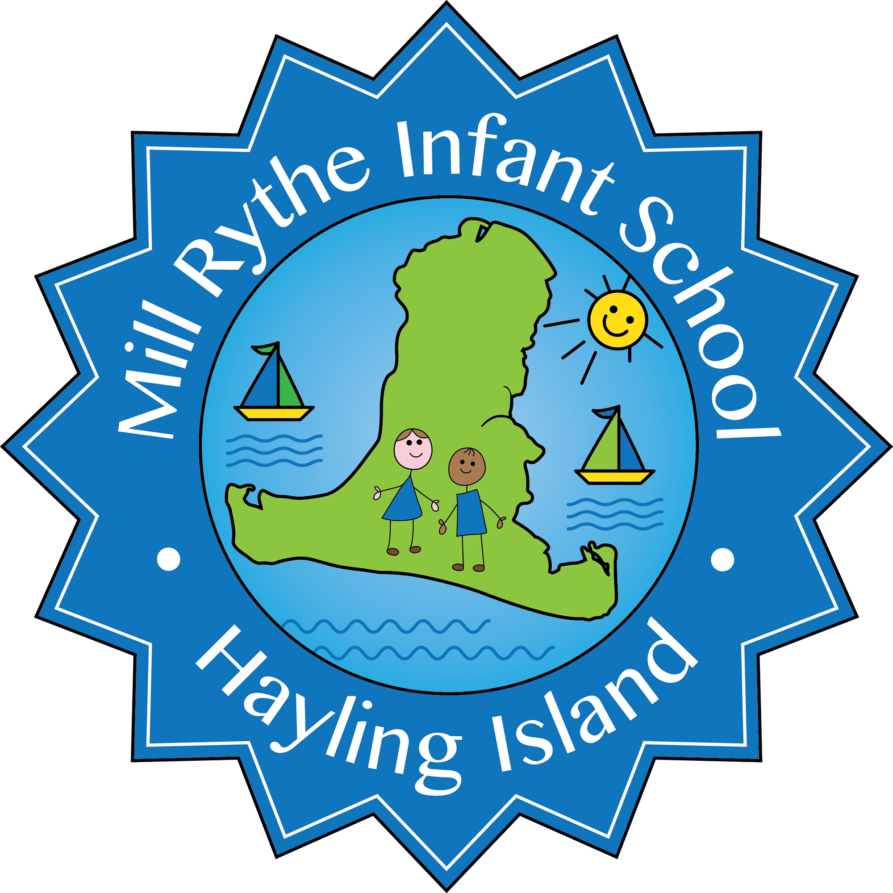

CHANGE OF DETAILS FORM
Please would you complete where relevant, sign and date.

Child’s Name …………………………………….. Class …………..………………………

Child’s New Address ………………………………………………………………………….
……………………………………………………………………………………………………
New Home Telephone Number ………………………………………………………………

New Mobile Telephone Number (Mum) …………………………………………………….
New Mobile Telephone Number (Dad) ……………………………………………………..

New Work Telephone Number (Mum) ………………………………………………………
New Work Telephone Number (Dad) ……………………………………………………….

New Emergency Contact Name ……………………………………………………………..
Daytime Tel ………………………………………………………………………………….…
Relationship to child (ie. Aunt, friend, neighbour, etc) …………………………………….

Signature ………………………………………. Date …………………………………..…
Name …………………………….…………….. (Mother/Father/Other – please specify)

