**Mill Rythe Infant School**

**Admission Arrangements 2025-2026**

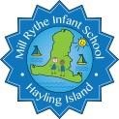

|  |  |  |  |
| --- | --- | --- | --- |
| **Document Information** | | |  |
| **Statutory:** | Yes | **Created by:** | Charlotte Tighe |
| **Reviewed by:** | FGB | **Responsibility:** | FGB |
| **Last review:** | December 2023 | **Next review:** | December 2024 |
| **Review cycle:** | Annual | **Ratified by FGB:** |  |
| **Signature (Chair of Governors):** | | |  |

This admissions policy will be used during 2025/2026 for allocating places in the main admission round for entry to Year R in September 2025. It will also apply to in-year admissions during 2025-2026.

The Governing Body of Mill Rythe Infant School is the admission authority for the school. The admission arrangements are determined by the Governing Body, after statutory consultations. The policy aims to be clear, fair and objective and complies with all relevant legislation.

|  |
| --- |
| **Published Admission Number (PAN)** |

Each school has a published admission number (PAN) for entry to Year R. The school will admit this number of children if there are sufficient applications. Where there are fewer applications than the published admission number, places will be offered to all applicants.

Our Published Admission Number (PAN) is **60.**

|  |
| --- |
| **Admission Process** |

Applications for a space at Mill Rythe Infants can be made via <https://www.hants.gov.uk/educationandlearning/admissions>. Alternatively, a paper copy of the application is available via the school office. The admission authority will consider first all those applications received by the published deadline of midnight on 15 January 2025. Notifications to parents offering a primary school place will be sent by the County Council on 16 April 2025.

Applications made after the deadline will be considered after all on-time applications have been fully processed unless exceptional circumstances merit consideration alongside on-time applications. For the normal admission round, all on time applications will be considered simultaneously and ranked in accordance with the admission criteria.

|  |
| --- |
| **Pupils with an Education, Health and Care Plan (EHCP)** |

Any child with an Education, Health and Care Plan naming Mill Rythe Infant School will be admitted. Where possible such children will be admitted within the PAN.

|  |  |
| --- | --- |
| **Oversubscription Criteria** |  |

If the school is oversubscribed, after the admission of pupils with an Education, Health and Care plan naming the school, priority for admission will be given to children in the following order:

* + 1. Looked after children or children who were previously looked after but immediately after being looked after became subject to an adoption, residence, or special guardianship order. (*See definition i)*
    2. Children or families who have a serious medical, physical or psychological condition which makes it essential that the child attends Mill Rythe Infant School rather than any other. (Appropriate medical or psychological evidence must be provided in support from an independent professional) Each application must include appropriate supporting evidence from an independent professional such as a doctor and/or consultant for medical needs or a social worker, health visitor, housing officer, police officer or probation officer for social needs. The evidence must confirm the child or family’s medical or social need and why that need(s) makes it essential that the child only attends Mill Rythe Infant School rather than any other. (*See definition ii)*

* + 1. Children of staff (*see definition iii)* who have, (1) been employed at Mlll Rythe Infant School for two or more years at the time at which the application for admission to the school is made, or (2) have been recruited to fill a vacant post for which there is a demonstrable skill shortage.

* + 1. Children living **within** the catchment area of Mill Rythe Infant School (*see definition iv)*, who at the time of application, have a brother or sister (including children living as siblings in the same family unit) on roll at the linked school, Mill Rythe Junior School and who will still be on roll at the time of the sibling’s admission.

* + 1. Children living **outside** the catchment area of the school who at the time of application have a brother or sister (including children living as siblings in the same family unit) (*see definition v)* on the roll of Mill Rythe Infant or the linked Junior school, Mill Rythe Junior School and who will still be on roll at the time of the sibling’s admission. [Where a sibling was allocated a place at Mill Rythe Infant school or the linked junior school, Mill Rythe Junior School in the normal admission round in a previous year because the child was displaced (*see definition vi*) from the catchment school for their address, the application will be considered under 4 above, subject to the siblings still living in the catchment area for the school from which they were displaced. In future normal admission rounds a younger sibling will be considered to have been displaced where they were allocated a place at Mill Rythe Infant School or the linked junior school, Mill Rythe Junior School, under this criterion as a consequence of their elder sibling’s displacement are still living in the catchment area for the school from which they where displaced].

* + 1. Children living **within** the catchment area that do not fall within any other criteria.

* + 1. Children living **outside** the catchment area that do not fall within any other criteria.

**Definitions**

1. A looked after child is a child who is (a) in the care of a local authority, or (b) being provided with accommodation by a local authority in the exercise of their social services functions (see the definition in section 22(1) of the Children Act (1989). An adoption order is an order under section 12 of the Adoption Act 1976 and under section 46 of the Adoption and Children Act 2002. A ‘child arrangement order’ is an order settling the arrangements to be made as to the person with whom the child is to live under section 8 of the Children Act 1989 as amended by Section 12 of the Children and Families Act 2014. Child arrangements orders replace residence orders and any residence order in force prior to 22 April 2014 is deemed to be a child arrangements order. Section 14A of the Children Act 1989 defines a ‘special guardianship order’ as an order appointing one or more individuals to be a child’s special guardian (or special guardians).] Previously looked after children also includes those who appear (to the admission authority) to have been in state care outside of England and ceased to be in state care as a result of being adopted. A child is regarded as having been in state care outside of England if they were in the care of or were accommodated by a public authority, a religious organisation, or any other provider of care whose sole or main purpose is to benefit society.
2. Applicants will only be considered under this criterion if on the application form (online or paper) they have ticked the appropriate box explicitly indicating that they wish for their application to be considered under medical / social need. ‘Medical need’ does not include mild medical conditions, such as asthma or allergies. ‘Social need’ does not include a parent’s wish that a child attends the school because of a child’s aptitude or ability or because their friends attend the school or because of routine childminding arrangements. Priority will be given to those children whose evidence establishes that they have a demonstrable and significant need to attend Mill Rythe Infant School. Equally, this priority will apply to children whose evidence establishes that a family member’s physical or mental health or social needs mean that they have a demonstrable and significant need to attend Mill Rythe Infant School. Evidence must confirm the circumstances of the case and must set out why the child should attend Mill Rythe Infant School and why no other school could meet the child’s needs. Providing evidence does not guarantee that a child will be given priority at Mill Rythe Infant School and in each case a decision will be made based on the merits of the case and whether the evidence demonstrates that a placement should be made at Mill Rythe Infants above any other.

1. ‘Children of staff’ refers to situations where the staff member is the natural parent, the legal guardian or a resident stepparent.

1. A map of the school’s catchment area is available on the school’s details page of the Hampshire County Council website [www.hants.gov.uk/educationandlearning/findaschool.](http://www.hants.gov.uk/educationandlearning/findaschool)

1. ‘Sibling’ refers to brother or sister, half-brother or half-sister, adoptive brother or adoptive sister, foster brother or foster sister, stepbrother or stepsister living as one family unit at the same address. It will also be applied to situations where a full, half or adopted brother or sister are living at separate addresses. Criteria 4 and 6 include children who at the time of application have a sibling for whom the offer of a place at Mill Rythe Infant School or the linked junior school, Mill Rythe Junior School, has been accepted, even if the sibling is not yet attending. It also includes, in the normal admissions round, children who have a sibling on roll in Year 2 at Mill Rythe Infant School at the time of application, who are successful in gaining a place at the linked junior school, Mill Rythe Junior School, on the national notification date.

1. ‘Displaced’ refers to a child who was refused a place at the catchment school in the normal admissions round having named it in the application and was not offered a higher named preference school. To identify the child’s catchment school please use the following link: [www.hants.gov.uk/educationandlearning/findaschool.](http://www.hants.gov.uk/educationandlearning/findaschool) Note that some addresses are in catchment for more than one school and in this case, displaced refers to a child who was refused a place at any of their catchment schools.

|  |
| --- |
| Tie-Breaker |

If Mill Rythe Infants has more applications than spaces within the PAN then the Oversubscription Criteria will be used. If, when using this criteria, there are two or more applications of equal eligibility and insufficient places to accommodate these children within the PAN, then straight line distance will be used to prioritise applications; applicants living nearer the school have priority. Distances will be measured from the Ordnance Survey home address point to the school address point using Hampshire County Council’s Geographic Information Systems (GIS). Distances to multiple dwellings will give priority to the ground floor over the first floor and so on. On individual floors, distances will be measured to the stairs leading to the communal entrance. Where two or more applicants are equidistant, random allocation will be used to allocate the space. An explanation of the random allocation procedure is available here: <https://documents.hants.gov.uk/education/Random-Allocation.pdf>

|  |  |
| --- | --- |
| **Additional Information** |  |

|  |
| --- |
| Permanent Residence |

The child’s permanent residence is where they live, normally including weekends and during school holidays as well as during the week, and should be used for the application. The permanent address of children who spend part of their week with one parent and part with the other, at different addresses, will be the address at which they spend most of their time. Where a child’s time is evenly divided between the parents, parents must agree which address they would like to be considered for the purposes of the application. In the event of a dispute, in the absence of a relevant court order, the admission authority will make a judgement about which address applies, taking into account the address registered with the child’s current school, nursery, preschool or childminder, the address registered for child benefit and the address registered with the child’s GP.

|  |
| --- |
| Multiple Births |

Where a twin or child from a multiple birth is offered the last place available within the PAN, any further twin or child of the same multiple birth will be admitted, if the parents so wish, even though this may raise the intake number above the school’s PAN. The PAN will remain unchanged so that no other pupil will be admitted until a place becomes available within the PAN.

|  |
| --- |
| Waiting List |

Waiting lists will be established for each year group where more applications are received than places available. For main round admissions to Year R, the waiting list will be maintained centrally by the local authority until 31 August 2025. At all other times, and for other year groups, waiting lists will be operated by schools on behalf of the local authority.

Any places that become available will be offered to the child at the top of the list on the day the place became available. The waiting list is ordered according to the Oversubscription Criteria with no account being taken of the length of time on the waiting list or any priority order expressed as part of the main admission round.

The waiting list will be reviewed and revised

* each time a child is added to, or removed from, the waiting list;
* when a child’s changed circumstances affect their priority;

For entry to Year R, the waiting list will remain open until 31 August 2025, at which point all names will be removed. For all other year groups, waiting lists will remain open until 31 August of each year. Parents who want their child to be considered for a place at the school in the following school year must submit a new in-year application in the August preceding the new school year. Schools will send a decision letter within the first 10 days of the new term.

|  |
| --- |
| Starting School |

Pupils born between 1 September 2020 and 31 August 2021 (inclusive) are entitled to full-time schooling from September 2025. Parents can choose to defer their child’s admission until later in the school year (but not beyond the start of the term after they reach compulsory school age). Children can also attend part-time until they reach compulsory school age. Parents must discuss their child’s starting arrangements with the school once an offer has been secured.

Children with birthdays between:

* + - * September and 31 December 2020 (inclusive) reach compulsory school age on 31 December 2025, at the start of the spring term 2026.
      * 1 January and 31 March 2021 (inclusive) reach compulsory school age on 31 March 2026, at the start of the summer term 2026.
      * 1 April and 31 August 2021 (inclusive) reach compulsory school age on 31 August 2026, at the start of the new school year in September 2026.

Parents of summer born children (those born between 1 April and 31 August) who are particularly concerned about their child’s readiness for school can request to delay their child’s entry to Year R for an entire school year until September 2026. This is called decelerated admission. In making such a request, parents would be expected to state clearly why they felt decelerated admission to Year R was in their child’s best interests. It is recommended that parents considering such a request contact the local authority in the Autumn term of 2024 to ensure that an informed decision is made. Guidance on decelerated admission for summer born children, including how to make a request, is available on the County website at [www.hants.gov.uk/ad-summerborn](http://www.hants.gov.uk/ad-summerborn).

|  |
| --- |
| In-Year admissions |

In year admission applications can be made via <https://www.hants.gov.uk/educationandlearning/admissions>. All applications for a school place made outside of the normal admissions rounds are subject to the same criteria as applications made during the main admissions round and places will be allocated in accordance with our admission policy. Where parents do not have access to the internet, a paper copy of the application form can be requested from the School Office or can be found in Appendix 1. Once completed it will then need to be sent to the Hampshire admissions team.

|  |
| --- |
| Admission of children outside of their normal age group |

Parents may request that their child is admitted outside their normal age group. To do so, parents should include a request with their application, specifying why admission outside the normal age group is being requested and which year group they wish their child to be admitted. Decisions will be made based on the circumstances of the case and in the best interests of the child.

|  |
| --- |
| Appeals |

All applicants refused a place have a right of appeal to an independent appeal panel constituted and operated in accordance with the School Admission Appeals Code. If a child is refused a place at Mill Rythe Infant School, their parent will be informed of the reason for refusal in writing and informed of their right to appeal. The parent will also be provided with a deadline and contact details for lodging an appeal. If an appeal is lodged then the grounds for the appeal must be set out by the parent in writing.

|  |
| --- |
| Legislation |

This arrangement takes account of all equalities legislation, together with all relevant regulations and the School Admissions Code (DFE 2021).

**Appendix 1**

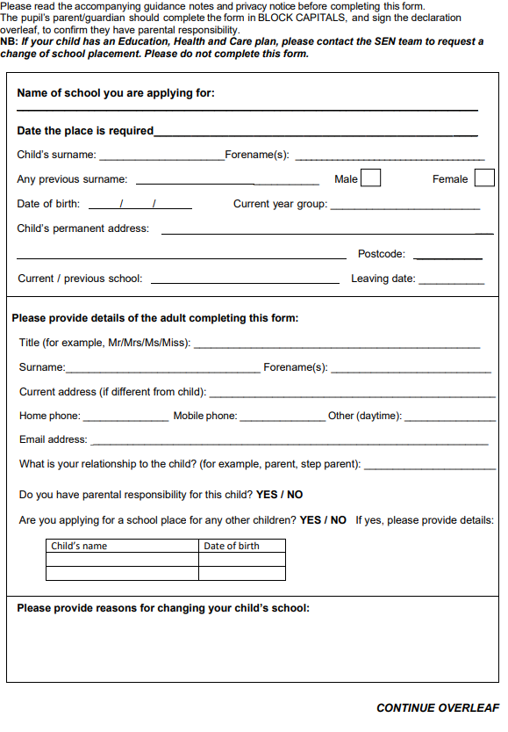**Application for a school place in-year**

